

**Semester 2 Examination, 2012**

**Question/Answer Booklet**

**MATHEMATICS**

**3C/3D (Year 12)**

**Section One:**

**Calculator-free**

Your name:

Your teacher: S Ebert T Hosking S Rowden

**Time allowed for this section**

Reading time before commencing work: five minutes

Working time for paper: fifty minutes

**Material required/recommended for this section**

***To be provided by the supervisor***

This Question/Answer booklet

Formula sheet

***To be provided by the candidate***

Standard items: pens, pencils, pencil sharpener, eraser, correction fluid/tape, ruler, highlighters

Special items: nil

**Important note to candidates**

No other items may be used in this section of the examination. It is **your** responsibility to ensure that you do not have any unauthorised notes or other items of a non-personal nature in the examination room. If you have any unauthorised material with you, hand it to the supervisor **before** reading any further.

**Structure of this paper**

|  |  |  |  |  |
| --- | --- | --- | --- | --- |
| Section | Number of questions available | Number of questions to be answered | Working time (minutes) | Marks available |
| Section One:  Calculator-free | 7 | 7 | 50 | 50 |
| Section Two:  Calculator-assumed | 13 | 13 | 100 | 100 |
|  | | | | 150 |

**Instructions to candidates**

1. The rules for the conduct of Western Australian external examinations are detailed in the *Year 12 Information Handbook 2012*. Sitting this examination implies that you agree to abide by these rules.
2. Write your answers in the spaces provided in this Question/Answer Booklet. Spare pages are included at the end of this booklet. They can be used for planning your responses and/or as additional space if required to continue an answer.

* Planning: If you use the spare pages for planning, indicate this clearly at the top of

the page.

* Continuing an answer: If you need to use the space to continue an answer, indicate

in the original answer space where the answer is continued, i.e. give the page number. Fill in the number of the question(s) that you are continuing to answer at the top of the page.

1. **Show all your working clearly**. Your working should be in sufficient detail to allow your answers to be checked readily and for marks to be awarded for reasoning. Incorrect answers given without supporting reasoning cannot be allocated any marks. For any question or part question worth more than two marks, valid working or justification is required to receive full marks. If you repeat an answer to any question, ensure that you cancel the answer you do not wish to have marked.
2. It is recommended that you **do not use pencil** except in diagrams.

Section One: Calculator-free (50 Marks)

This section has**seven (****7)** questions. Answer **all** questions. Write your answers in the space provided.

Working time for this section is 50 minutes.

Question 1 (5 marks)

For the two independent events  and ,  and .

Calculate

(a) 

[1]

(b) 

[1]

(c) 

[2]

(d) 

[1]

**Question 2 (5 marks)**

Solve the system of equations



Question 3 (7 marks)

(a) Differentiate the following with respect to. **There is no need to simplify your answer**.

(i) 

[2]

(ii) 

[2]

(b) Simplify 

[3]

**Question 4 (9 marks)**

A function is defined by .

(a) Find the coordinates of the turning points of  and state their nature.

[4]

(b) Find the coordinates of the point of inflection of .

[1]

(c) Sketch the graph of . Show clearly the key features.

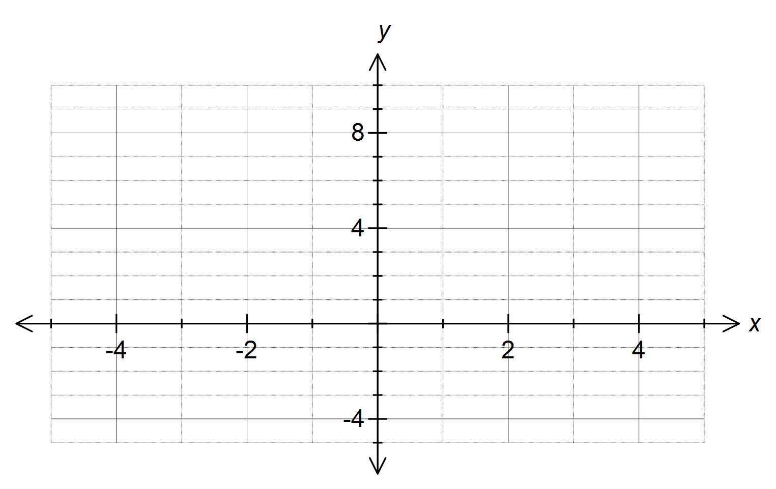

[3]

(d) What is the maximum value of  in the interval ?

[1]

Question 5 (8 marks)

Let  and .

(a) Determine the domain of .

[2]

(b) Determine the range of .

[2]

(c) Solve .

[4]

**Question 6 (9 marks)**

(a) Determine 

[3]

(b) Calculate the area bounded by the functions  and .

[6]

Question 7 (7 marks)

A closed cylindrical can of radius  cm has a volume of  cm3.

(a) Show that the total surface area,  cm2, of this can is given by .

[2]

(b) Determine the minimum possible surface area of the can and the radius and height required to achieve this optimum area.

[5]

**Additional working space**

Question number(s):

**Additional working space**

Question number(s):